**Chapter 1**

**INTRODUCTION**

* 1. **Background**

The main purpose of this mini project is aimed at developing a system which reduces work burden of employees of the organization. Every Organization has some maintenance and budget planning. In this situation submitting the bills to their corresponding managers will be a headache and we have to maintain records manually. Some times in manual process there is a possibility to get errors. To overcome these difficulties and time constraints, it is best to use this type of application. Here, the employees in the organization submit the bills to their managers. The bills could be of various types and also of various amounts. The employee after submitting the bill will automatically provide the manager’s name to which the bill will be submitted. The bill will pass through a workflow process and the owner of the bill can view the status of the bill at any time.

* 1. **Introduction about the project**

This mini project is aimed at developing a system by which the employees in the organization submit the bills to their managers. The bills could of various types and also of various amounts. The employee after submitting the bill will automatically provide the manager’s name to which the bill will be submitted. The bill will pass through a workflow process and the owner of the bill can view the status of the bill at any time. The software is fully integrated with CRM (Customer Relationship Management) as well as CMS (Content Management System) solution and developed in a manner that is easily manageable, time saving and relieving one from manual works. This mini project is very popular and a similar implementation is widely used in many big organizations by employees for submitting various types of bills to their seniors. This is an online system and is used maintain most of the activities happening in big organizations.

**Chapter 2**

**ER DIAGRAM AND RELATIONAL SCHEMA DIAGRAM**

**2.1 Entity-Relationship Diagram**

An entity relationship diagram, usually referred to as an ER diagram represents the attributes, entities and relationships in a relational schema design.

* Entity types like EMPLOYEE and BILLS are represented using rectangular boxes in the ER diagram.
* The attributes which characterize the entities are represented in ovals, each attached to the entity type using a straight line. The attribute which is designated as the primary key is identified by underlining it within the oval.
* Relationships like ‘Holds’, ‘Has’ are represented in diamond boxes which are attached to the entity types participating in the relationship using straight lines.
* The total participation of the entities participating in the relationship represented inside the rhombus is identified by two straight lines from the entity type to the diamond. Whereas, the partial participation is identified by a single line.
* The cardinality ratios are as follows:

1. Holds: Holds relation is of cardinality ratio 1: 1 as each employee can have only one designation at a time.
2. Belongs to: This relation is of cardinality ratio 1:1 as each employee can belong to only one department in the organization.
3. Has: Has relation is of cardinality ratio 1: N as each can have more than one bills generated to him at the same time.
4. Payed Through: This relation is of cardinality ratio 1: 1 as the bills of an employee are payed one at a time.
5. Monitors: The Monitors relation links Admin to all other entities in the database. This means that Admin controls all the entities in the database. The cardinality ratio is 1: N as one admin can monitor many entities at the same time.



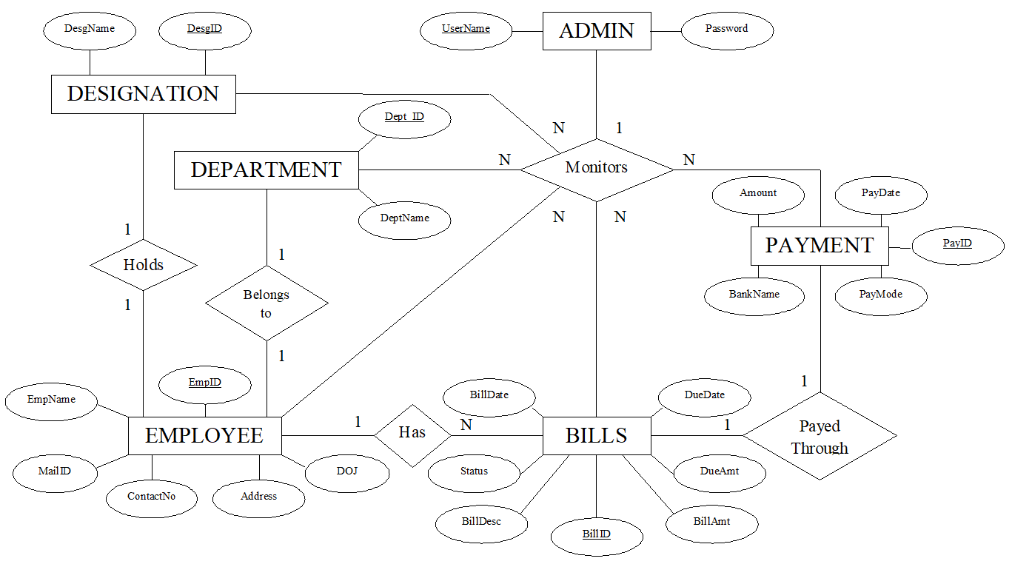

**Fig. 2.1 ER Diagram of Budget Planner**

**2.2 Relational Schema Diagram**

The term database schema refers to the description of the database that includes the database structure and various constraints on the database. The schema diagram is in turn an illustrative display of the database schema. The primary keys are underlined and the referential integrity constraints are depicted by arrows pointing to the keys they reference.

The tables are:

* EMPLOYEE: This table holds details of all Employees working in the organization. EmpID is the primary key. DeptId and DesgID are referenced from Department and Designation tables respectively.
* DEPARTMENT: This table holds details of all Departments in the organization. Dept_ID is the primary key of the table.
* DESIGNATION: This table holds details of all Designations available in the organization. DesgID is the primary key of the table.
* BILLS: This table stores details of the Bills of all the employees in the organization. BillID is the primary key. EmpID is referenced from Employee table.
* PAYMENT: This table stores the payment details of the bills. PayID is the primary key. BillID is referenced from the Bills table.

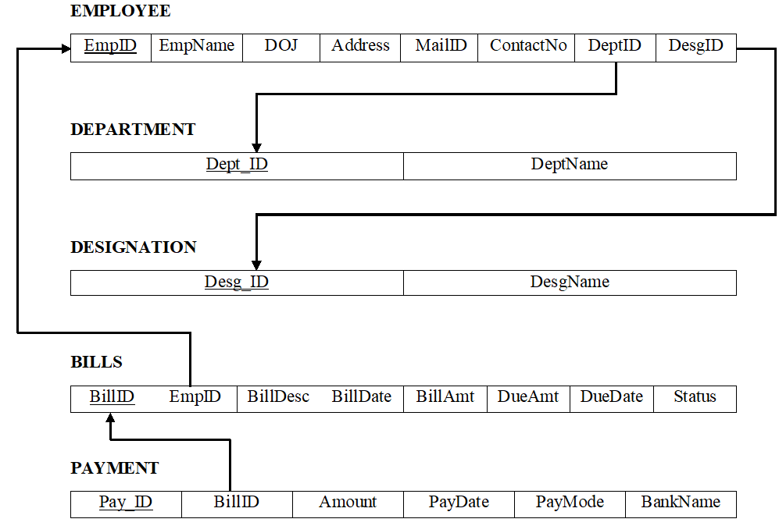

**Fig. 2.2 Schema Diagram of Budget Planner**

**Chapter 3**

**SYSTEM DESIGN**

**3.1 Tables Description**

**1. EMPLOYEE**

**Fig. 3.1 Employee Table**

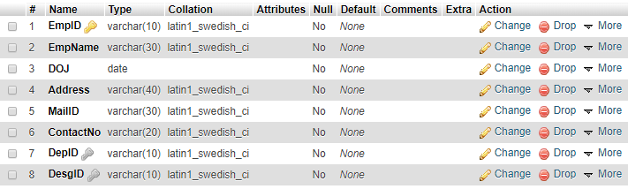

This table holds the details of all employees working in the organization. The admin has the privilege to register new employees. These new details will be stored in the EMPLOYEE table. Employee has no privileges to add or view other details. He can only view details of his concerned Bill.

**2. DEPARTMENT**

**Fig. 3.2 Department Table**



This table holds details of the various departments in an organization. Every employee belongs to one of the departments in this table. The Dept_ID along with DeptName attributes are set to Primary key.



**3. DESIGNATION**



**Fig. 3.3 Designation Table**

This table holds details of all the designations available to the employees. Designation tells what kind of work an employee does in the organization. DesgID is the primary key of the table.

**4. BILLS**

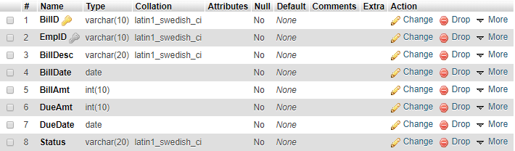

**Fig. 3.4 Bills Table**

This table holds the most important part of the project. It holds details of the various bill in an organization. BillID is the primary key of the table used to differentiate between different bills. The attribute EmpID is referenced from EMPLOYEE table.



**5. PAYMENT**

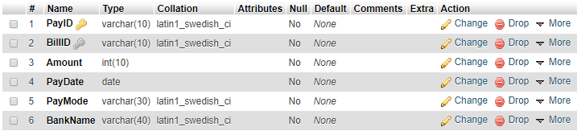

**Fig. 3.5 Payment Table**

This table holds details about how each bill is cleared. Its main attributes are PayID which is the primary key, PayDate which tells the date of payment and PayMode which tells the mode of payment. The attribute BillID is referenced from BILLS table.

**3.2 System Requirements**

**3.2.1 Hardware Requirements**

* Processor: PIV 2.8 GHz Processor and Above
* Main Memory: RAM 512MB and Above
* Secondary Memory: HDD 20 GB Hard Disk Space and Above

**3.2.2 Software Requirements**

* OS: WINDOWS OS (XP / 2000 / 200 Server / 2003 Server)
* Server: XAMPP (Cross Platform, Apache, MySQL, PHP, Perl)
* Front End: PHP
* Back End: MySQL (Built-in with XAMPP)

C**hapter 4**

**IMPLEMENTATION**

**4.1 Front end and Back end used**

**4.1.1 Front-end: HTML, CSS**

HTML is used as the front-end tool to design web pages because:

* It is easy enough to write, use and understand
* HTML also allows the use of templates, which makes designing a webpage easy
* All browsers support HTML

CSS is used along with html to design the web pages as it’s relatively easy to learn and produces better and cleaner code than applying all those styles directly to your HTML:

* Easy to maintain and update
* Greater consistency in design and more formatting options
* Greater accessibility

**4.1.2 Backend: PHP and MySQL**

MySQL is a free-to-use, open-source database that facilitates effective management of databases by connecting them to the software. It is a stable, reliable and powerful solution with advanced features like the following:

* MySQL is globally renowned for being the most secure and reliable DBMS used in popular web applications.
* MySQL features a distinct storage-engine framework that facilitates system administrators to configure the MySQL database server for a flawless performance.
* MySQL tops the list of robust transactional database engines available on the market with features like complete atomic, consistent, isolated, durable transaction support.

PHP (Hypertext Pre-Processor) is a server-side web programming language that is widely used for web development. MySQL is used with PHP as the back end tool.

* PHP also has powerful output buffering that further increases over the output flow.
* PHP is dynamic. PHP works in combination of HTML to display dynamic elements on the page.
* PHP can be used with a large number of relational database management systems, runs on all of the most popular web servers and is available for many different operating systems.

**4.2 Discussion of Code Segments**

PHP code for login is given below

<?php

$username = $_POST['user']; //extract username from front end

$password = $_POST['pass']; //extract password from front end

if ($username&&$password)

{

$connect = mysqli_connect("localhost","root","","budgetplanner") or die("Couldn't Connect");

//mysql_select_db("myqb") or die("Cant find DB"); // command use for connectivity

$query=mysqli_query($connect,"SELECT* FROM admin1 WHERE username='$username'");

$numrows = mysqli_num_rows($query);

if ($numrows!=0)

{

while($row = mysqli_fetch_assoc($query))

{

$dbusername = $row['username']; // comparing values from database



$dbpassword = $row['password'];

}

}

if ($username==$dbusername&& $password==$dbpassword)

{

echo "<center>Login Successfull..!! <br/>Redirecting you to HomePage! </br>If not Goto<a href='index.html'> Here </a></center>";

echo "<meta http-equiv='refresh' content ='2; url=login.html'>";

$_SESSION['username'] = $username;

}

else{

echo"Invalid Username or Password";

}

}

?>

**4.3 Applications of project work**

* This mini project is very popular in many big organizations used by employees for submitting various types of bills to their seniors.
* It can be used to keep track of financial resource leakage in an organization and minimize these losses.
* It is used to greatly enhance decision making process because of faster processing of information since data collection from information available on computer takes much less time than manual system.
* This project can be implemented to keep track of the personal expenses of an individual over a period of time.
* It can also be used as a Company Database that stores the information about various aspects of an organization.

**4.4 Discussion of the Results**

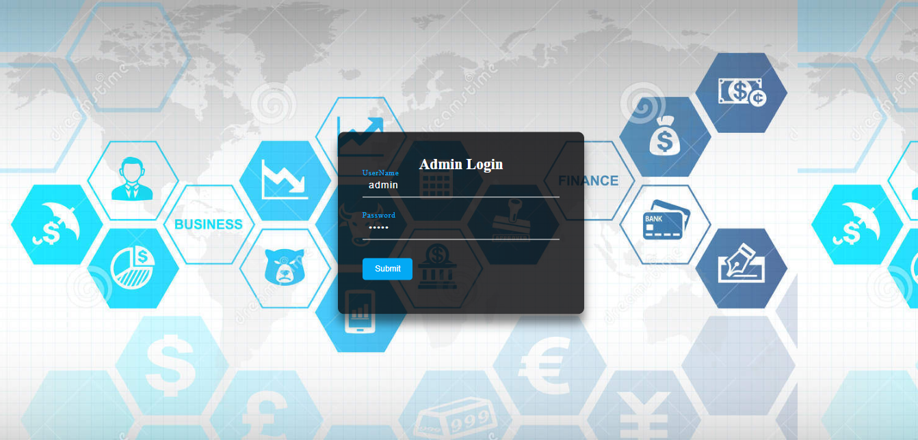

**Fig. 4.1 Admin Login**

Fig. 4.1 the login page where admin can login by entering correct username and password. If wrong details are entered, it shows ‘Invalid username or password. After logging in, admin can perform various operations on the database.

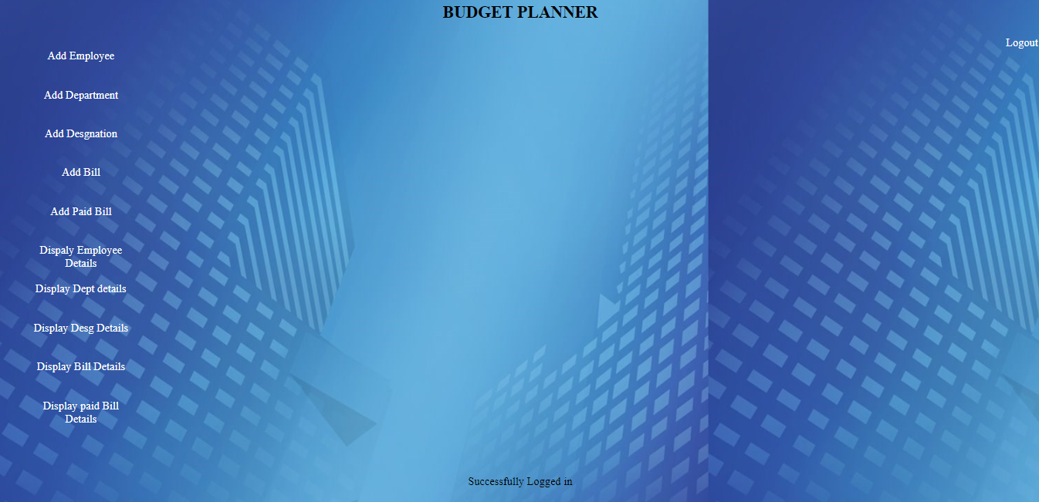

**Fig. 4.2 Admin Home**

Fig. 4.2 the admin home page where various operations are available to the admin. Admin can add or view details of Employee, Bill, Department, Designation and Paid Bill. Admin adds bills to employees, but he does not get bills of his own.

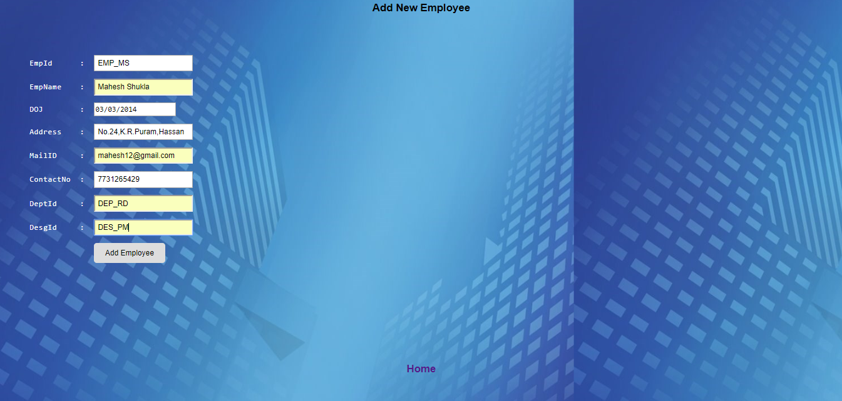

**Fig. 4.3 Add Employee**

Fig. 4.3 shows the page that lets the admin register new Employees. After entering the required details, the ‘Add Employee’ button adds the details to the database. The details of this employee can be viewed by using other options.

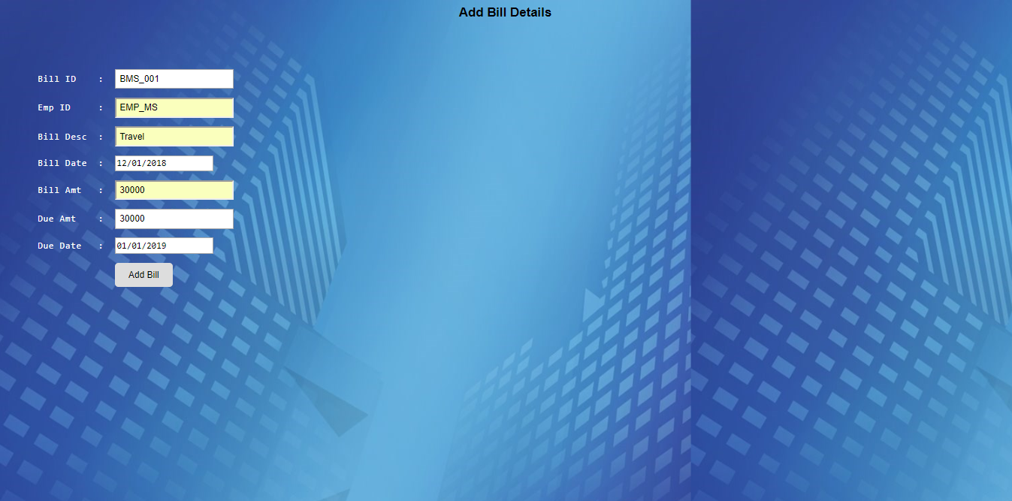

**Fig. 4.4 Add Bill**

Fig. 4.4 shows the page that lets the admin add bills to the employees. After entering the required details, the ‘Add Bill’ button adds the details to the database. The details of this Bill can be viewed by using other options.

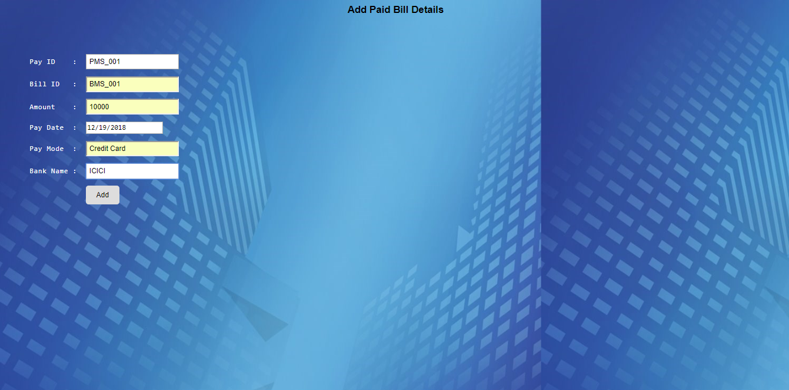

**Fig. 4.5 Add Paid Bill**

Fig. 4.5 shows the page to add details of bills that are paid. Bills are added to employees, so emp_id has to be specified. It gives information about the owner of the bill. The type of bill also has to be specified.

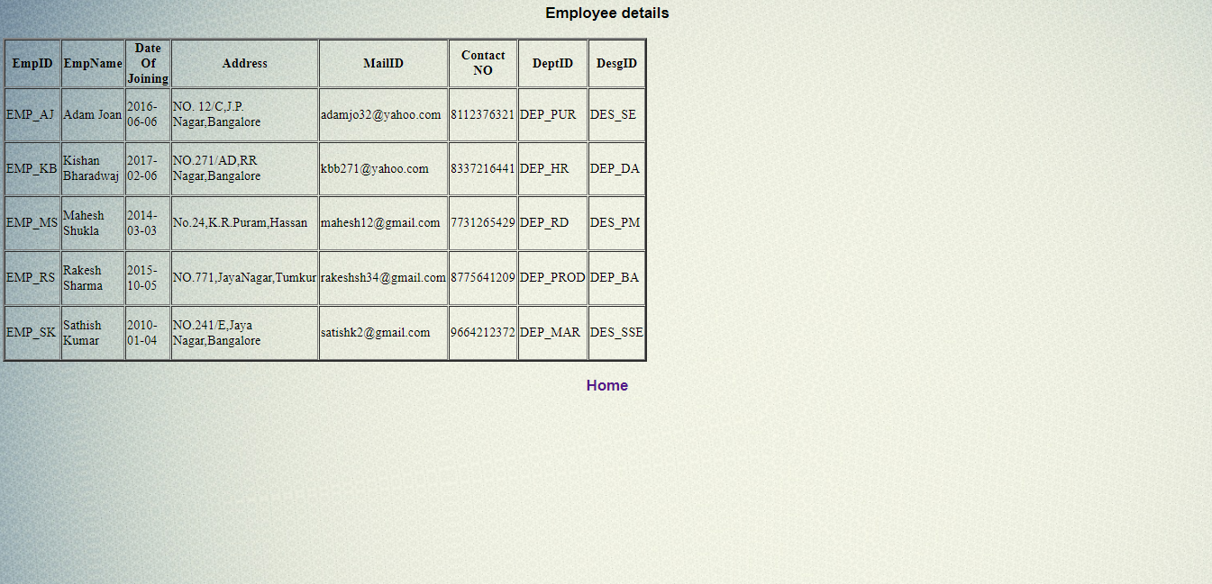

**Fig. 4.6 Employee details**

Fig. 4.6 displays employee details. All employees displayed here are a part of the organization. It also tells us the designation of the employee.

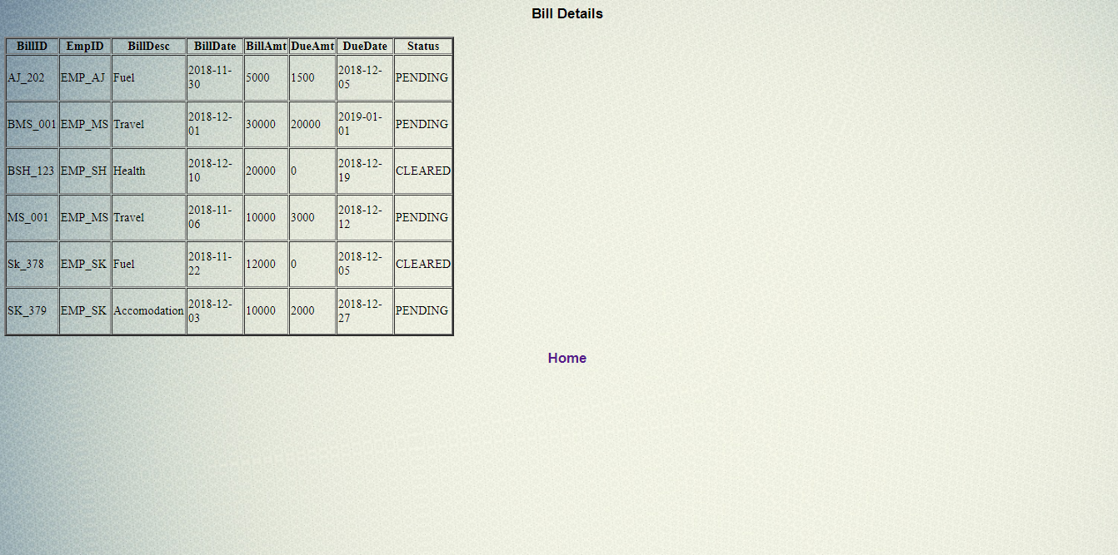

**Fig. 4.7 Bill details**

Fig. 4.7 displays the details of bills of all the employees in the organization. It shows the due date and due amount. Employee need not pay the due amount completely at once. It can be payed in instalments before the due date.

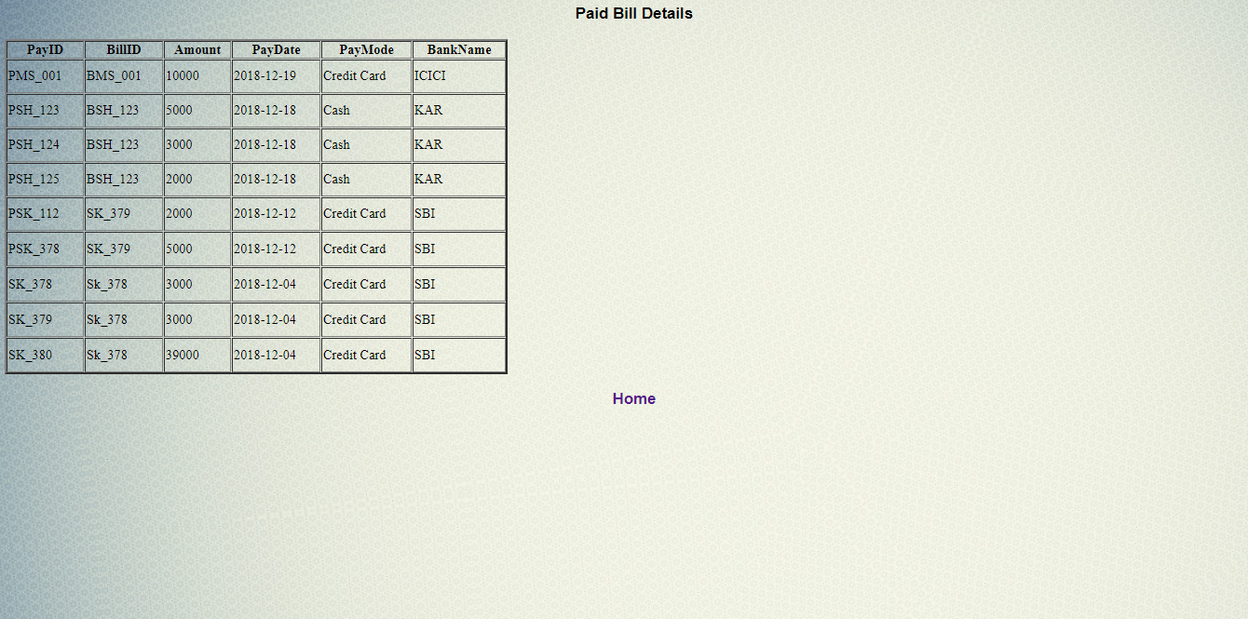

**Fig. 4.8 Paid Bill details**

Fig. 4.8 displays the details of all payed bills of the employees. It tells the amount payed by different employees. Employees should specify the bank to which bill has to be submitted.

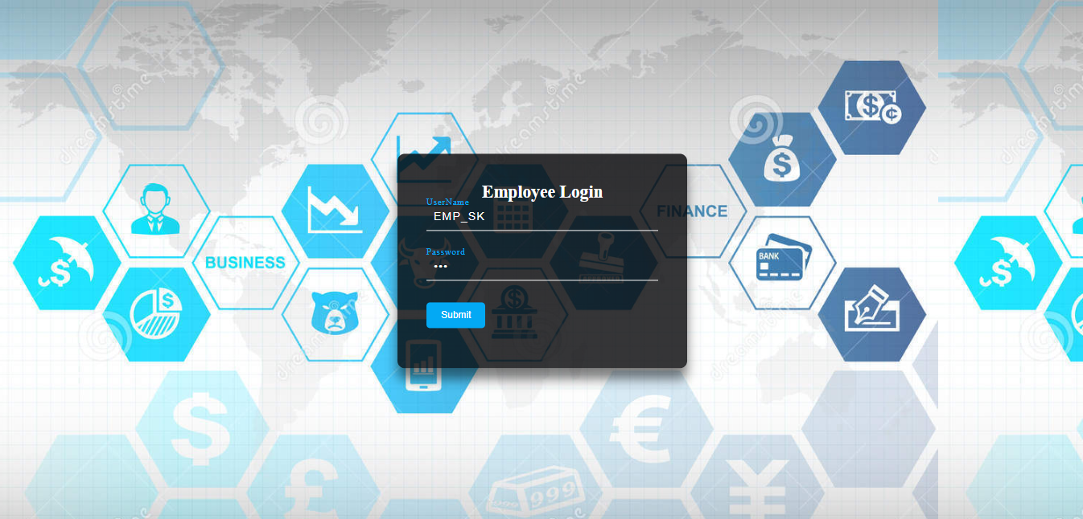

**Fig. 4.9 Employee Login**

Fig. 4.9 shows the employees’ login page where employees in the organization are allowed to login and use the application. Employee has no privilege to alter anything in the database.

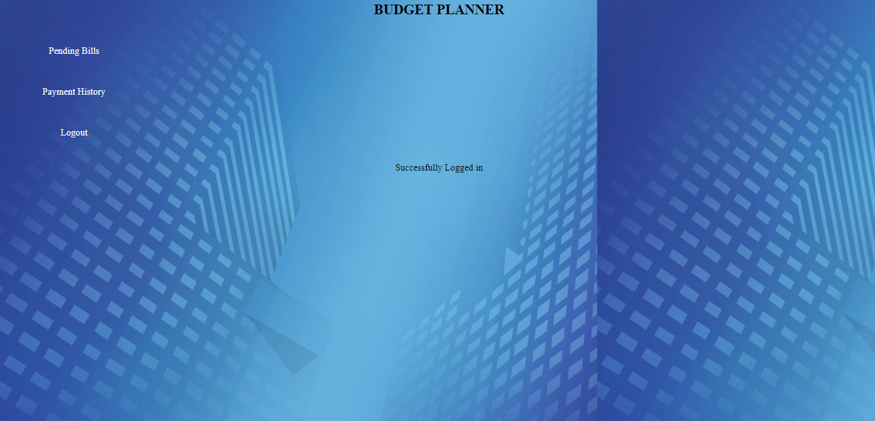

**Fig. 4.10 Employee Home**

Fig. 4.10 shows the home page of the employee. Employee can only view details available in the database. Employee cannot add or delete any details in the database.

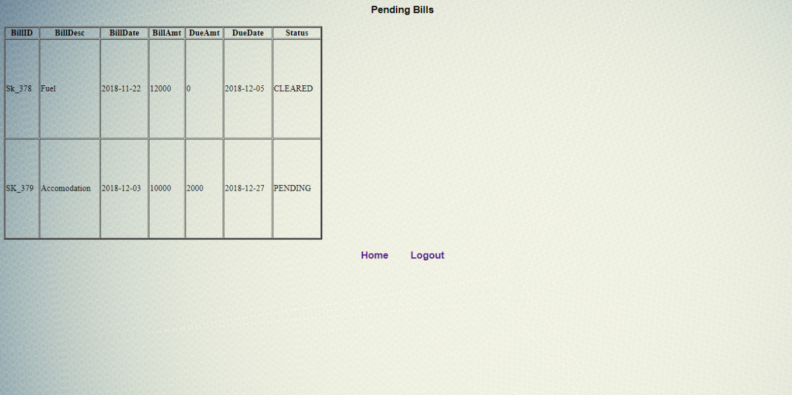

**Fig. 4.11 Pending Bills**

Fig. 4.11 shows the bills of an employee that are yet to be payed. If the due amount is completely payed, the status of the bill is set to ‘Cleared’. Otherwise it is set to ‘Pending’.

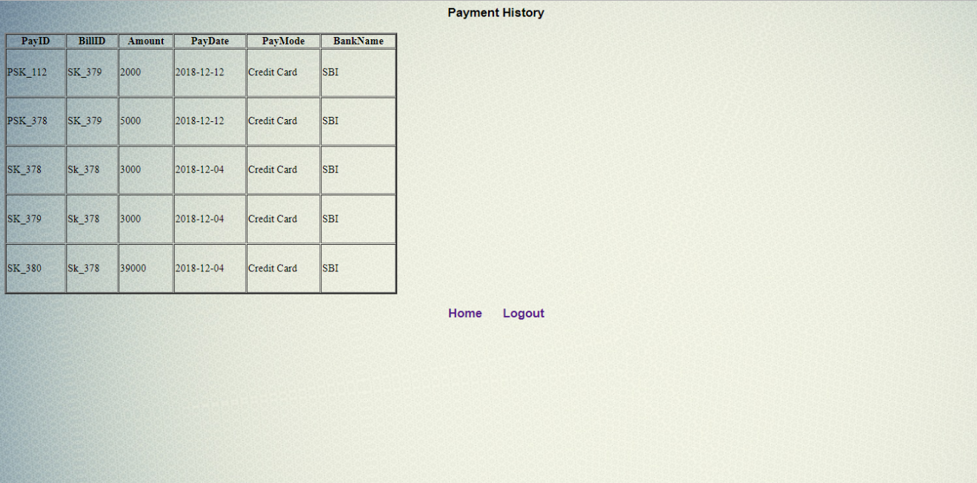

**Fig. 4.12 Payment History**

Fig. 4.12 shows the payment history of an employee. It gives complete information about how the employed has cleared the bill.

**Chapter 5**

**CONCLUSION AND FUTURE ENHANCEMENTS**

Having a software that calculates and generates bills of an organization on a regular basis is a great help for the employees of the organization. It has been setup to reduce the time taken to deal with bills and use that time in efficiently contributing to the growth of the organization. The primary goal is to overcome difficulties in manually trying to clear all bills. The software is designed to store all the details of the bills till it is cleared. This greatly reduces the workload the employees in an organization and also minimizes the risk of errors while dealing with the bills.

This System is web-based and is designed for major organizations. So, it needs to be thoroughly tested to find out if there are any security gaps. A console for the data center may be made available to allow the personnel to monitor on the sites which were cleared for hosting during a particular period. Moreover, it is just a beginning; further the system may be utilized in various other types of auditing operations like Network auditing or similar workflow based applications.

**REFERENCES**

1. Database Management Systems, 3rd edition by Raghu Ramakrishnan and Johannes Gehrke.
2. Fundamentals of Database Systems, 7th edition by Ramez Elmasri and Shamkant B Navathe
3. stackoverflow.com
4. w3schools.com
5. tutorialpoints.com
6. sololearn.com